 

2/2/2021

CENTRAL ZOO

E-Project

|  |  |
| --- | --- |
| **Group 4** | |
| **Instructor** | Mr. Nguyen Van Trong |
| **Group Members** | Hoang Trong Son  Le Dinh Tuan  Nguyen Thanh Hoai Chau |
| **Batch** | 162 |
| **Semester** | 1 |

**TECHER’S EVALUTION**

**MENU**

I. ACKNOWLEDGEMENTS 3

II. INTRODUCTION 4

III. REQUIREMENT 5

**1. User** 5

**2. Hardware** 5

**3. Software** 5

**4. Page** 5

IV. PROBLEM DEFINITION 7

**1. Homepage** 7

**2. Gallery** 7

**3. Ticket** 7

**4. Event** 8

**5. About** 8

**6. Contact** 8

**7. Navigation Bar** 8

**8. Footer** 9

V. SITE MAP 10

VI. GUI PROTOTYPE 11

VII. GUI OF WEBSITE 22

VIII. TECHNICAL 31

IX. REFERENCES 32

X. CHECKLIST 33

XI. PROJECT PLANNING 35

XII. CONCLUSION 36

# **I. ACKNOWLEDGEMENTS**

First of all, we would like to thank Mr. Nguyen Van Trong for helping us gain more knowledge, quick ways of doing things, the experiences that he has learned in the process of teaching and working. Thanks to these teaching methods, find out how to process and complete project implementary successfully. When implementing the SEM1 project which is also the first project we do, so the confusion and lack of experience to complete our work quickly is improbable. Fortunately, there are teachers who contribute, members of the accompanying group, and external documents, so the completion progress is also significantly faster.

Besides, we would like to thank Softech Aptech for providing an environment. study in a friendly, professional manner and important equipment in the project implementation process

Finally, we would like to thank everyone who helped us throughout the project. Although during the project implementation process, errors are inevitable, we hope that our project is recognized and evaluated in the most fairway.

Sincerely thank.

# **II. INTRODUCTION**

Our project is to develop a website about the zoo, which provides all information about the animals and their images, besides the sale of tickets to the zoo and events held there.

Back in the day when going to the zoo or similar locations, if it were the first time, people did not know what there would be there, or the long queue to buy tickets missed your family's outing plan.

Although you can check out ads in newspapers, radio stations, TV ... or check out our promotional flyer it has many limitations such as limited quantities, can’t be viewed anytime and anywhere if we need, and can’t display all the information on it. Understanding this, the CENTRAL Zoo website was launched to help people learn the key information before coming, as well as learning about the information of the animals that we have.

CENTRAL Zoo also allows you to purchase tickets online on the website, and pre-book events held by us at the zoo, saving you time for your trip that your family.

Understands the needs of operating a zoo, our team has developed the central zoo website design, supports CENTRAL zoo to advertise their brands and services widely on the internet. Help CENTRAL zoo develop further in the future.

# **III. REQUIREMENT**

## **1. User**

CENTRAL Zoo is created to serve 2 type of User:

* User who visit the website to buy ticket, see animal, commemorative phot or view information about wild animal.
* User who go to the zoo to travel and explore the zoo.

## **2. Hardware**

* Pentium 166 or better
* 64 Megabytes of RAM or better

## **3. Software**

* Notepad/ HTML editor
* Dreamweaver
* IE 5.0/ Netscape 6.0

## **4. Page**

1. The Home Page should be created making use of Sections with a suitable logo.

2. The look and feel of the project must be made user friendly and uniformity in the color combination must be maintained.

3. About us, Contact Us (address and map) must be added, it’s location displayed using GeoLocation API on the maps.

4. Animal’s information can be added in the categorized like birds, animals, water animals, and so on.

5. Safari option is there for which dummy booking option can be added.

6. Gallery of animals and birds must be added in the website.

7. Timings of the zoo must be added.

8. Navigation of the project must be made smooth.

9. Events organized (Informative for audience and for the welfare of the animals) must be noted.

10. Feedback and query can be added in the website.

11. Page:

* Home
* Gallery
* Library Photo
* Commemorative Photo
* Animal Detail
* Ticket
* Event
* About
* Contact

# **IV. PROBLEM DEFINITION**

## **1. Homepage**

This is the page where the user will be navigated after accessing the website successfully. On this page, we have introduced our zoo. The current status of endangered animals and the hunting of rare and precious animals in particular, and wildlife, in general, all over the world. We also suggested some solutions to protect wild animals. Display pictures and information about animals. Allow site visitors to navigate directly to image gallery pages, buy tickets and view upcoming events in the central zoo. Some customers' feedbacks after experiencing our zoo.

## **2. Gallery**

The gallery includes 4 items:

* ***Library Photo***

Gallery representing pictures of animals raised and preserved in the central zoo and some details about them. Display the number of animals in the central zoo.

* ***Commemorative Photo***

An archive of photos commemorating the souvenirs of visitors in the central zoo.

* ***Animal Details***

Photo and detailed information about distributed animals: terrestrial animals, aquatic animals, flying animals.

## **3. Ticket**

Ticket include two categories:

* ***Zoo Timing***

Zoo time programs on the opening day of the Central Zoo.

Information about the parking and the way to access the central zoo by different vehicles.

* ***Ticket***

This website allows you to buy tickets online at different prices for children, adults, the elderly, pairs, groups, and in groups with friends, you can also buy Central Zoo membership ticket.

## **4. Event**

When users want to preview upcoming events in the central zoo, they can click 'Events'. Here, users can also book events in advance by registering via the form or contacting us via the phone number displayed on the website.

After clicking the "Event" category, the user will see details about the Event such as photos, time, number of people who can attend and quick booking.

## **5. About**

This page introduces the history, mission, vision, and core values of CENTRAL Zoo.

Information about the management of the CENTRAL zoo.

## **6. Contact**

This page displays our address, email, phone number, and Social Network.

Display a form for you to fill out and provide us with your feedback.

Display map using Geolocation API.

## **7. Navigation Bar**

There is a logo of CENTRAL Zoo you can click to go to the homepage.

There are links to navigate to other pages of CENTRAL Zoo.

Gallery and Ticket use dropdown menus to drop down other links.

## **8. Footer**

There are links to CENTRAL Zoo's social networking sites such as Facebook, Twitter, Google Plus, Youtube, Instagram.

Display mission, opening hours, address, phone number, email ...of the Central Zoo.

There are quick links to Home, Ticket, About, Contact if the user pulls the end of websites.

# **V. SITE MAP**

Become a member

Buy Ticket

Ticket

Zoo Timing

Animals Detail

Commemorative Photo

Library Photo

Event booking

Past Events

Email

Phone Number

Address

ABOUT US

CONTACT

GALLERY

Ocean Animal

Terrestrial animal

Animal in fly

Upcoming Events

EVENT

**HOME**

TICKET

# **VI. GUI PROTOTYPE**

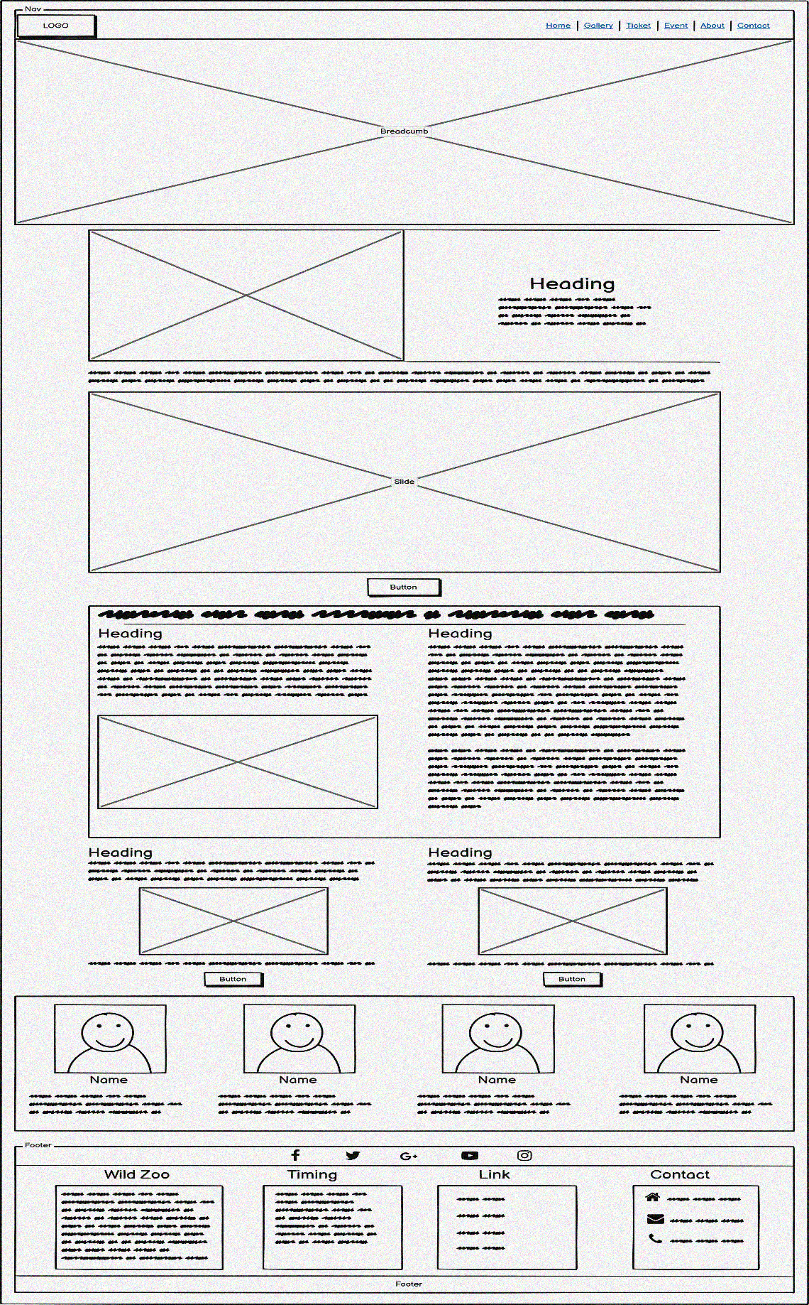

**Homepage**

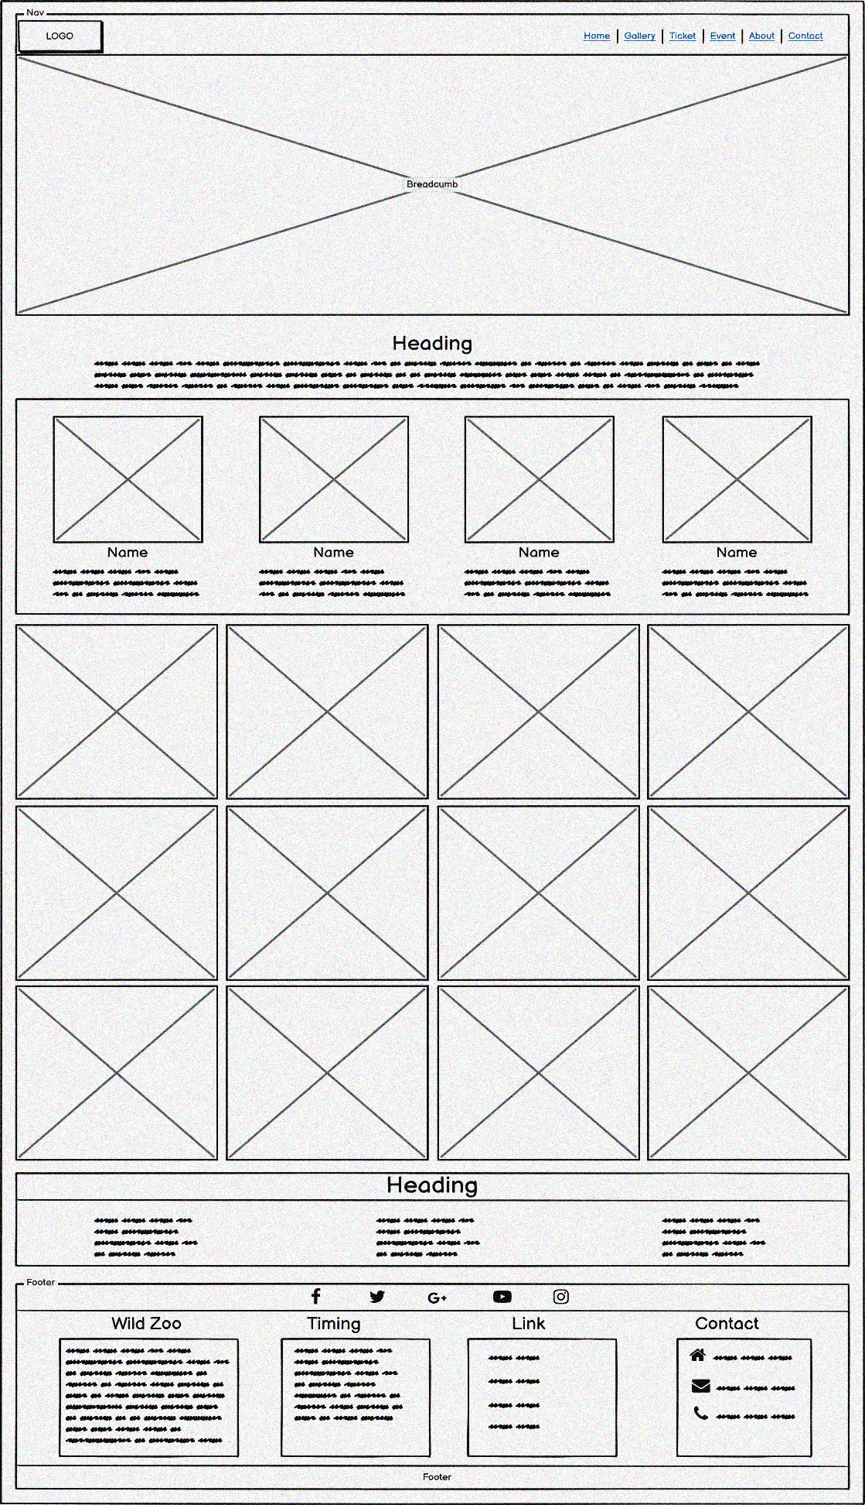

**Library Photo Page**

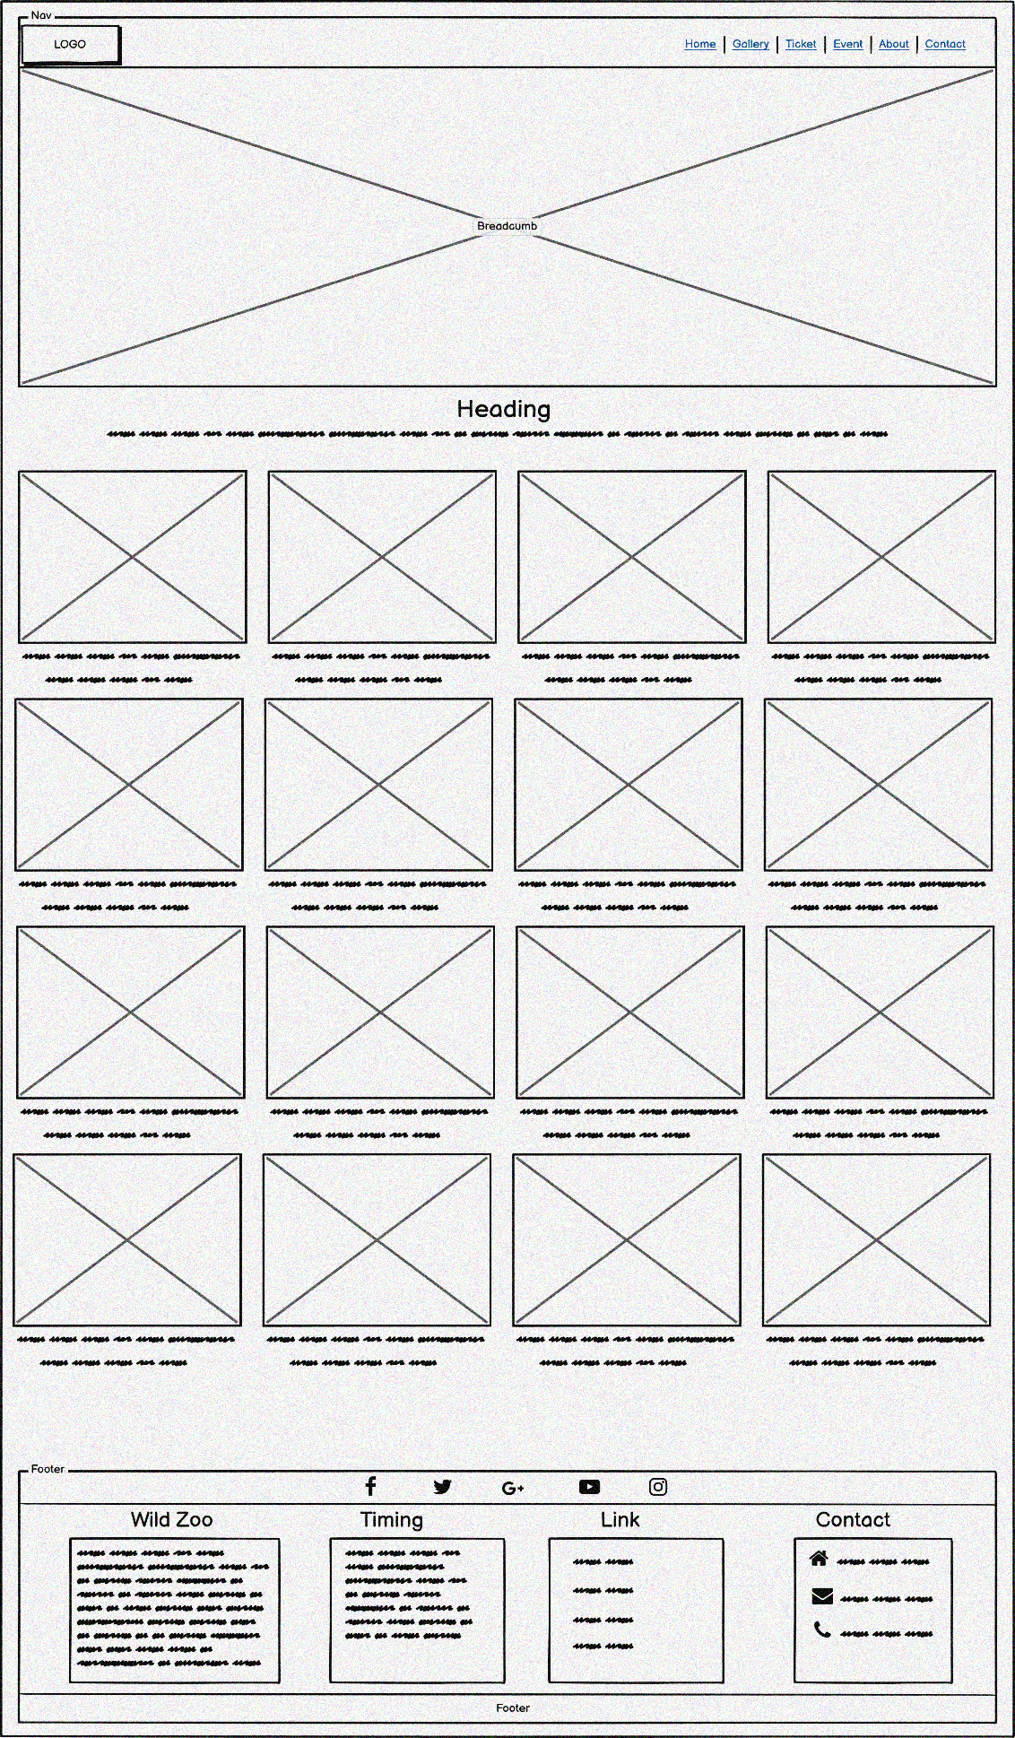

**Commemorative Photo Page**

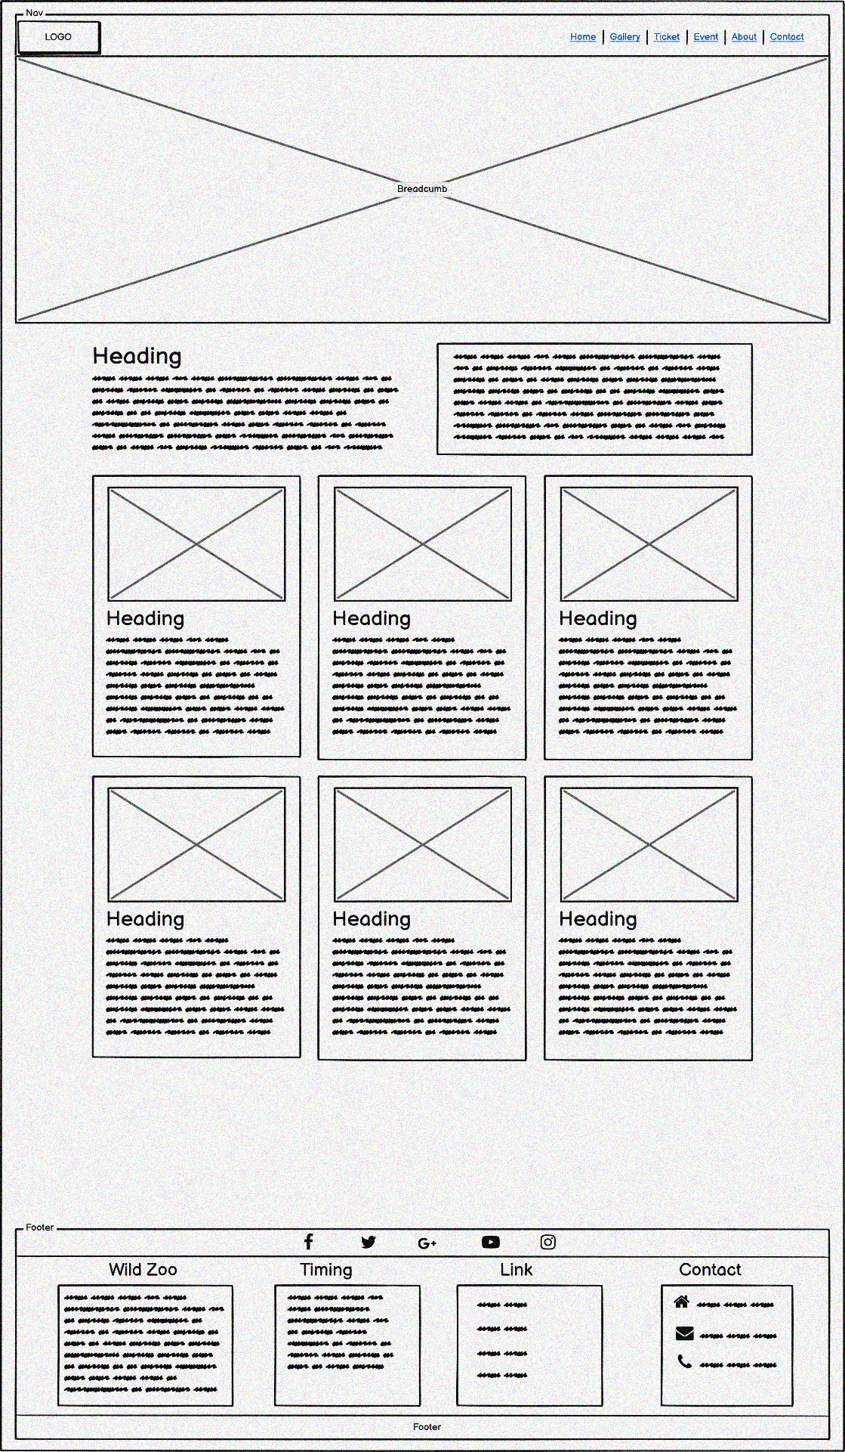

**Animal Detail Page**

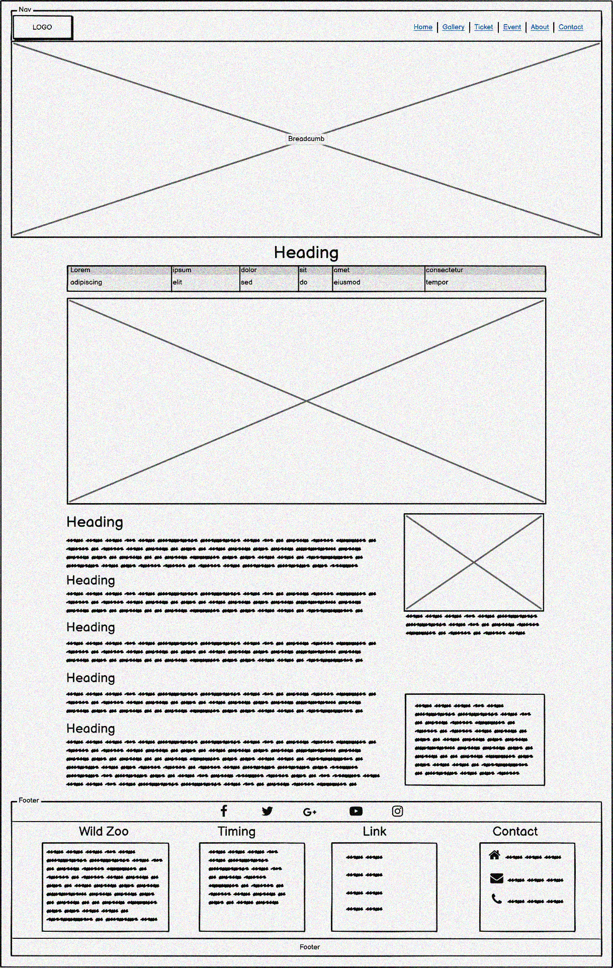

**Animal Detail – Elephant Page**

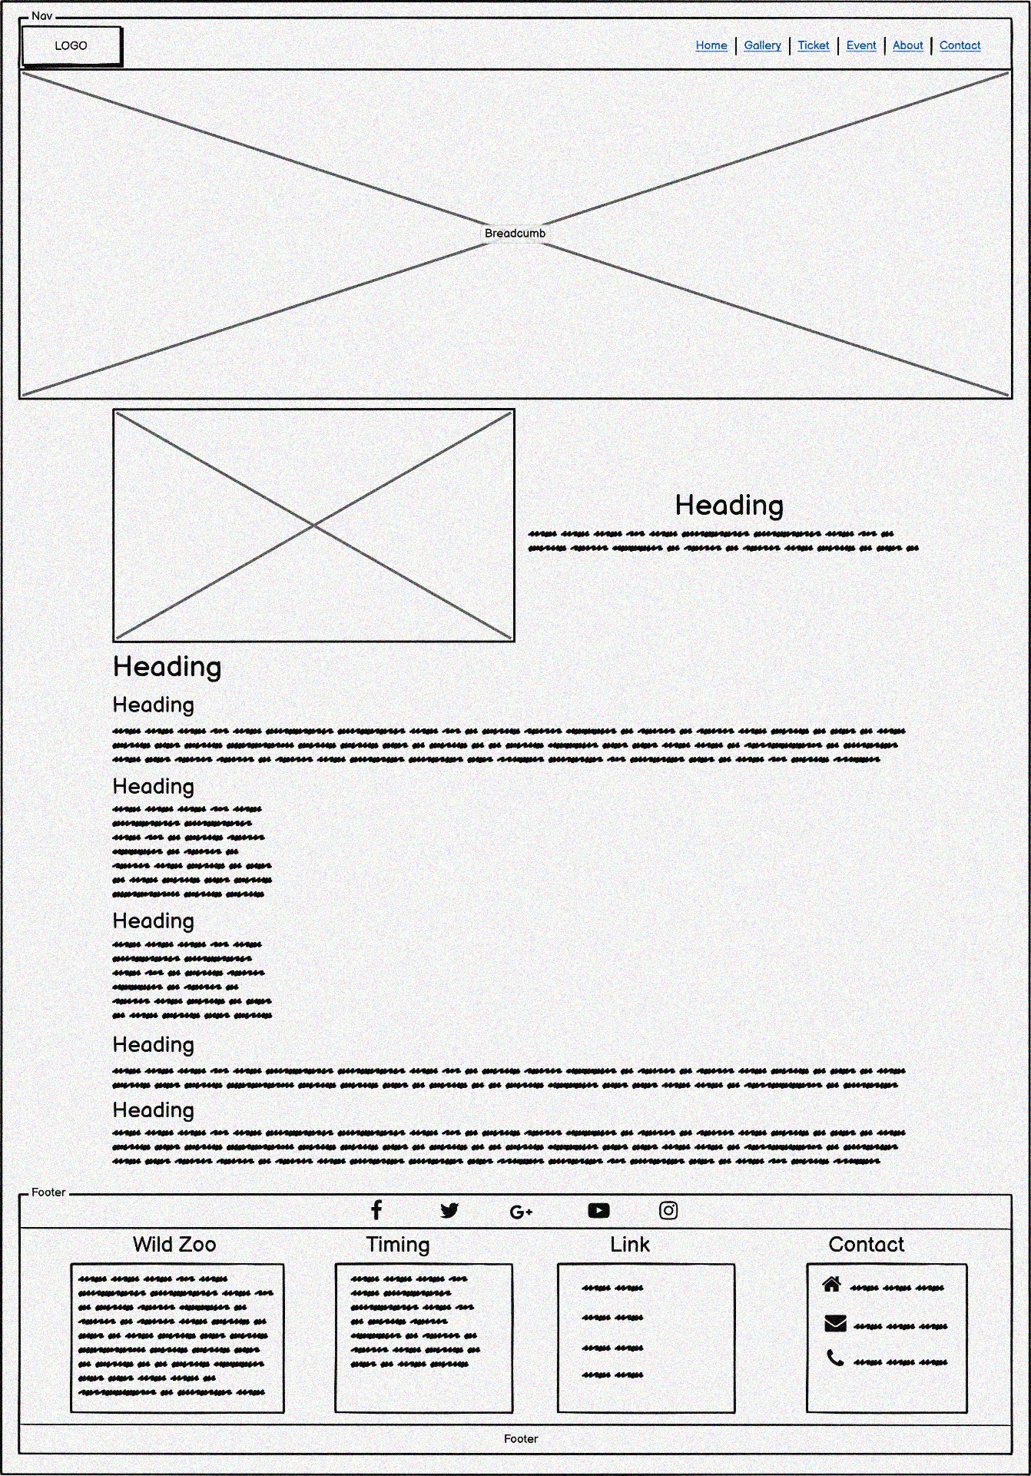

**Zoo Timing Page**

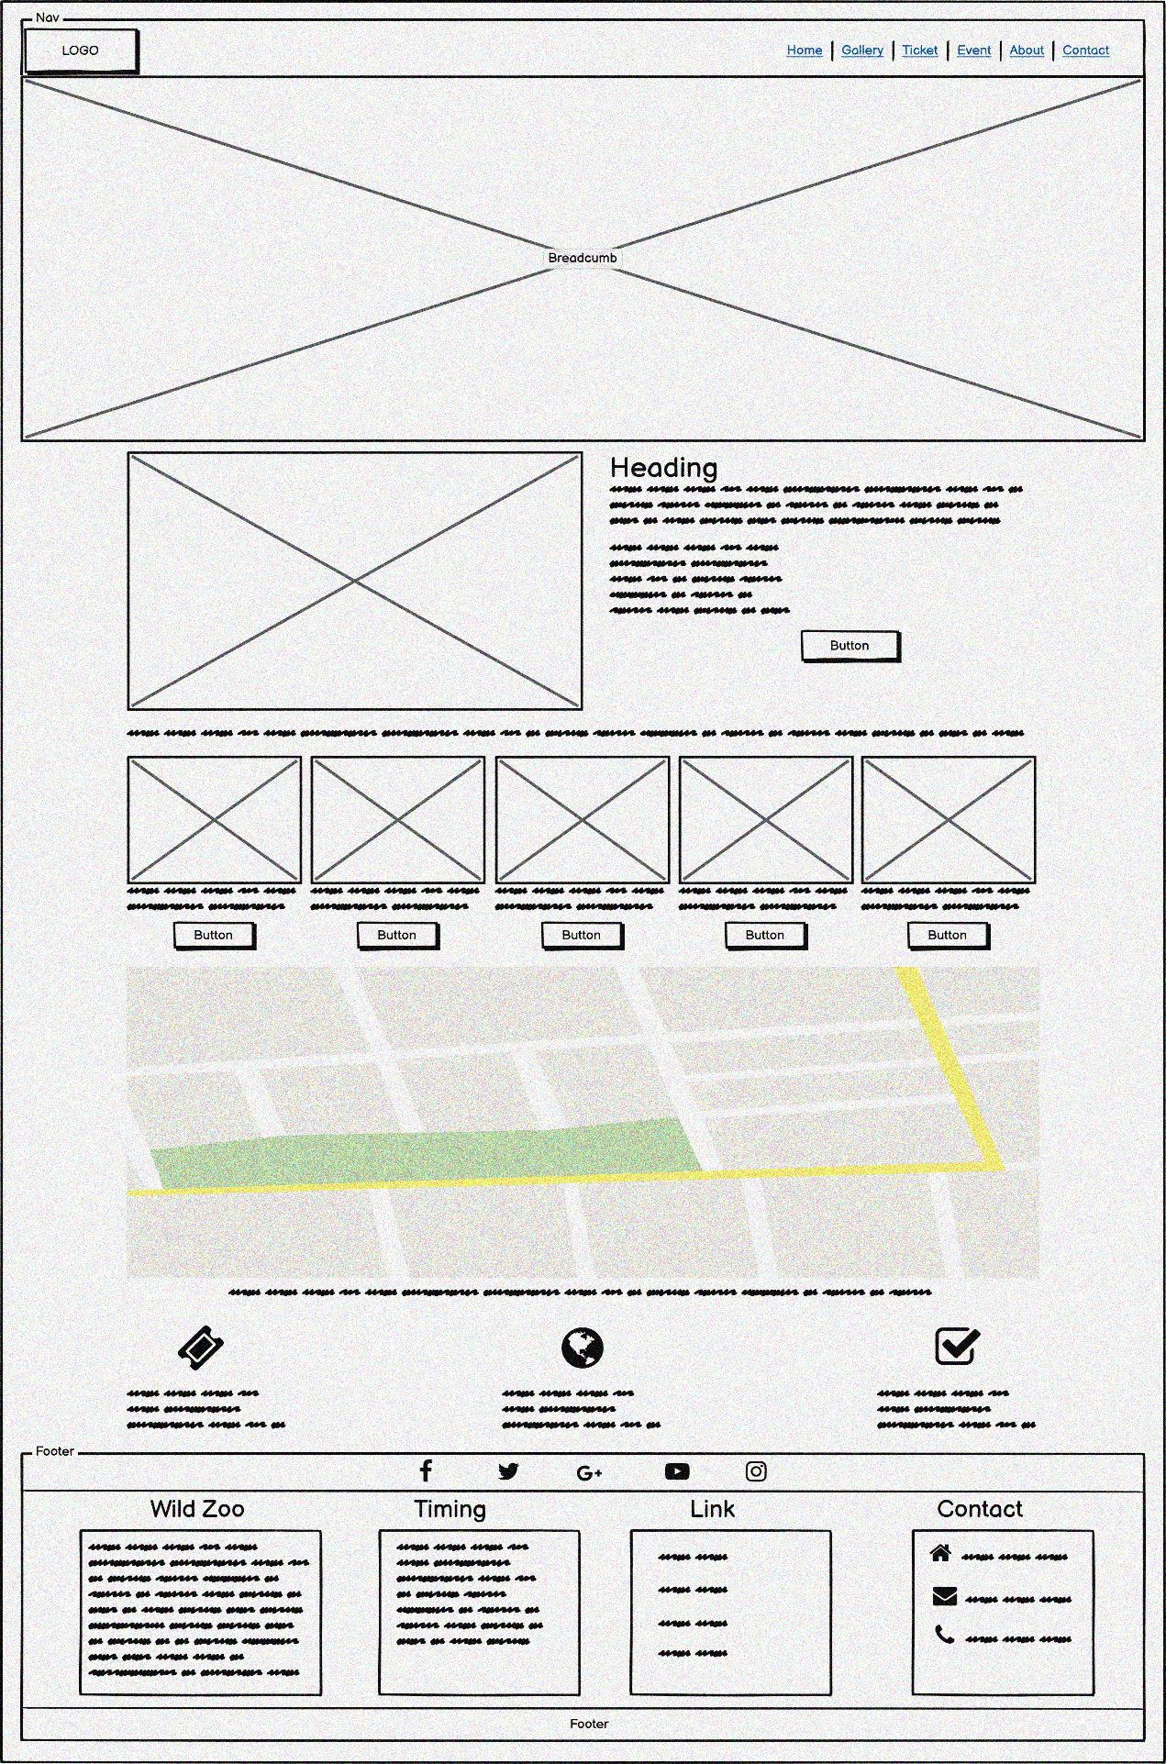

**Ticket Page**

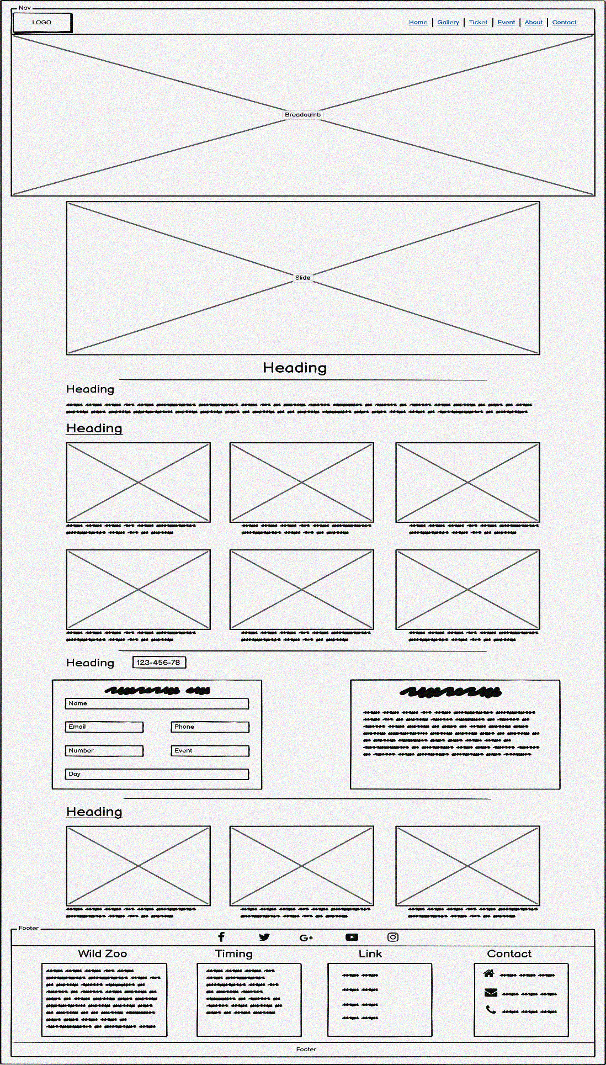

**Event Page**

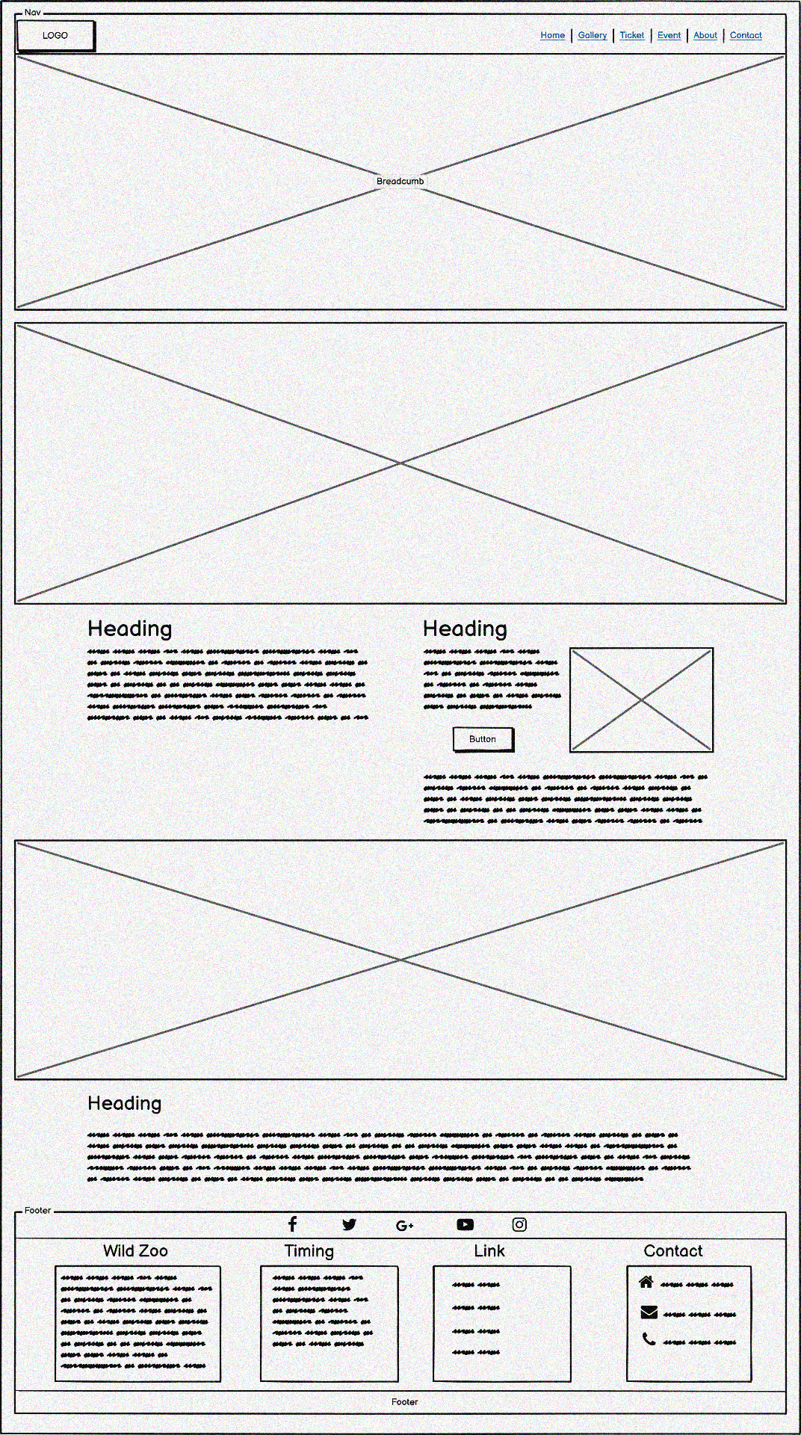

**Event Detail Page**

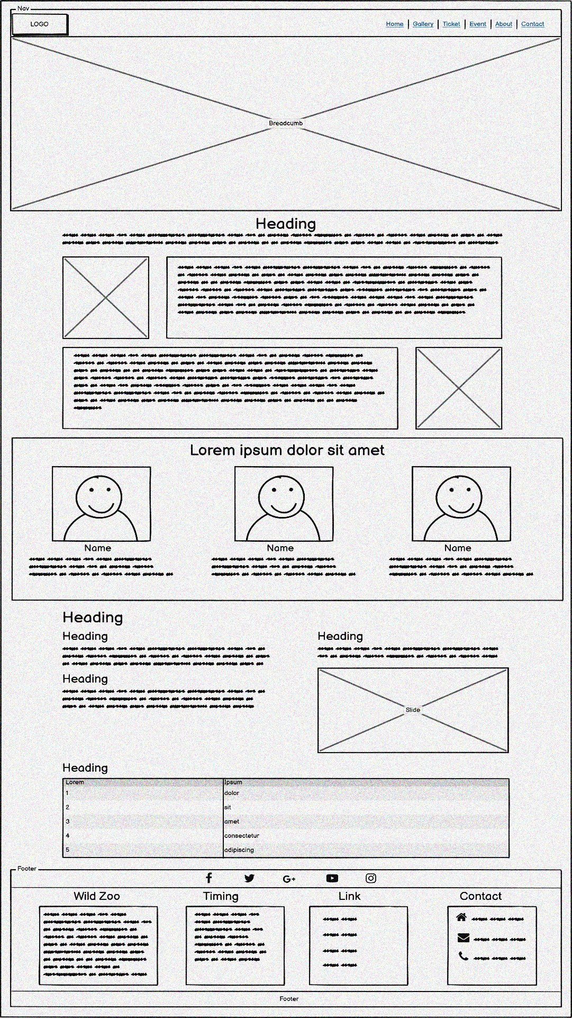

**About Page**

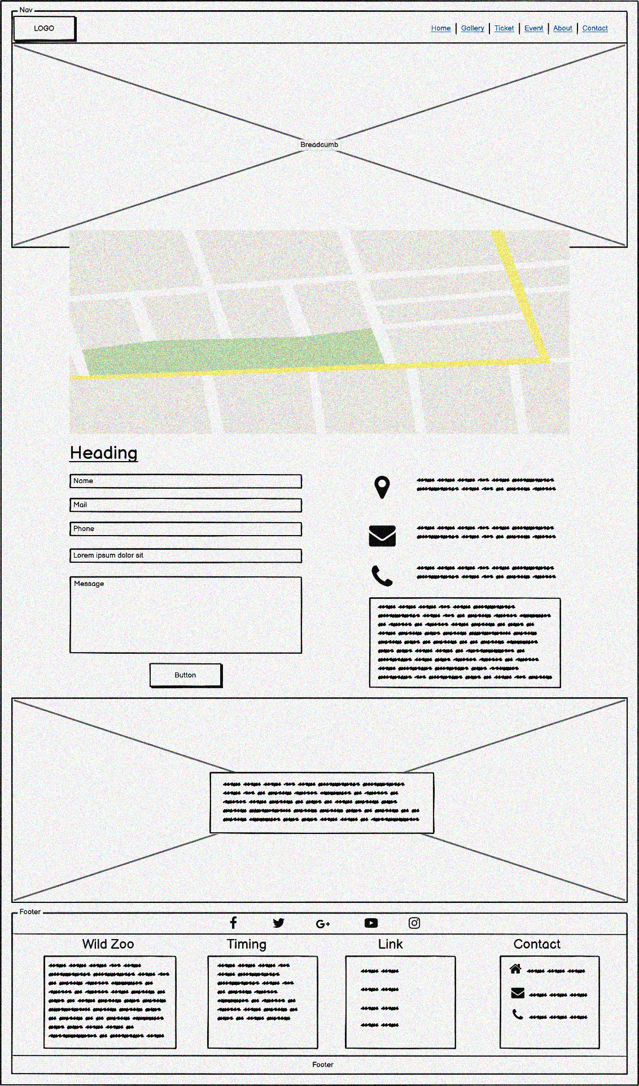

**Contact Page**

# **VII. GUI OF WEBSITE**

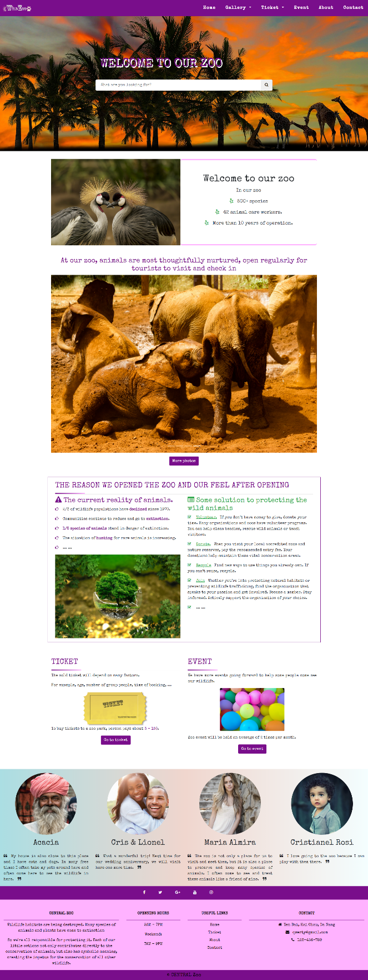

**Homepage**

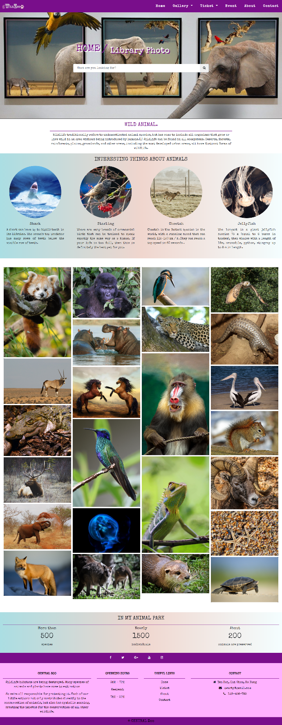

**Library Photo**

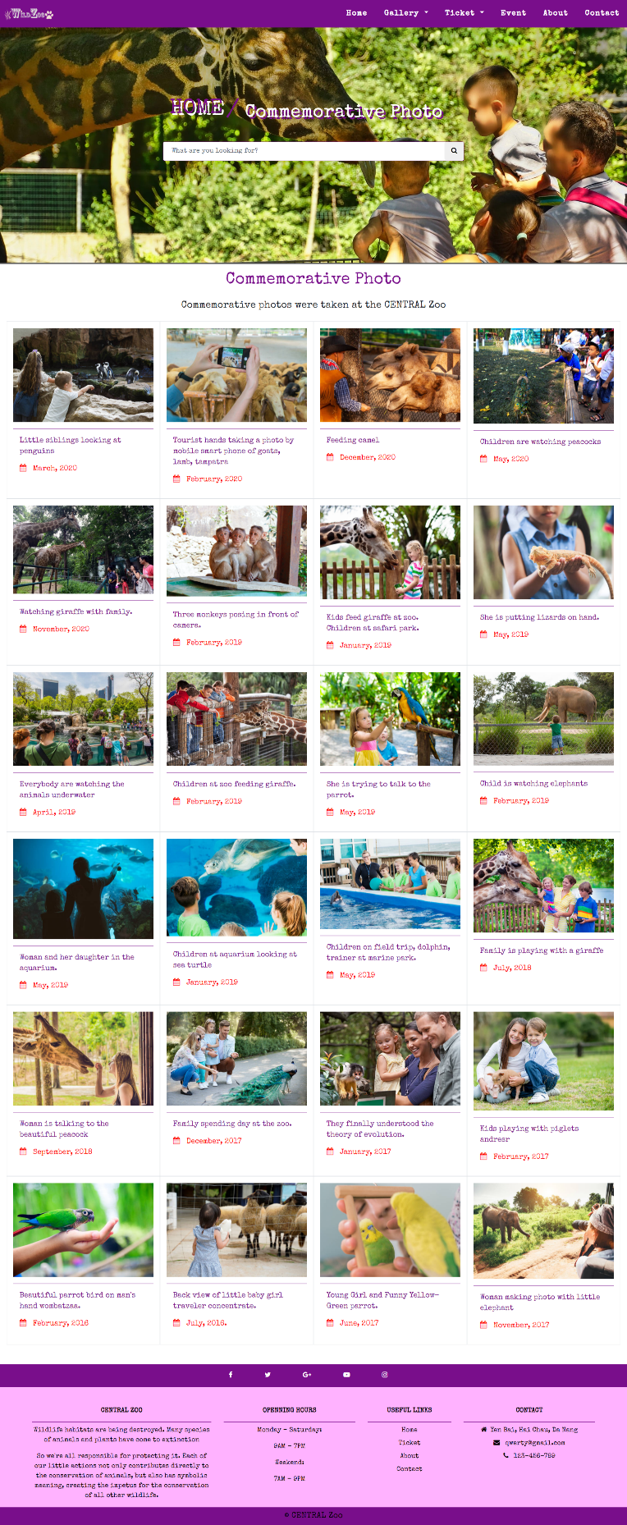

**Commemorative Photo**

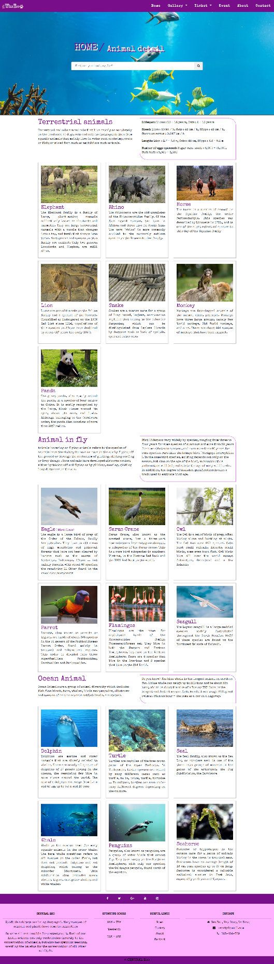

**Animal Detail**

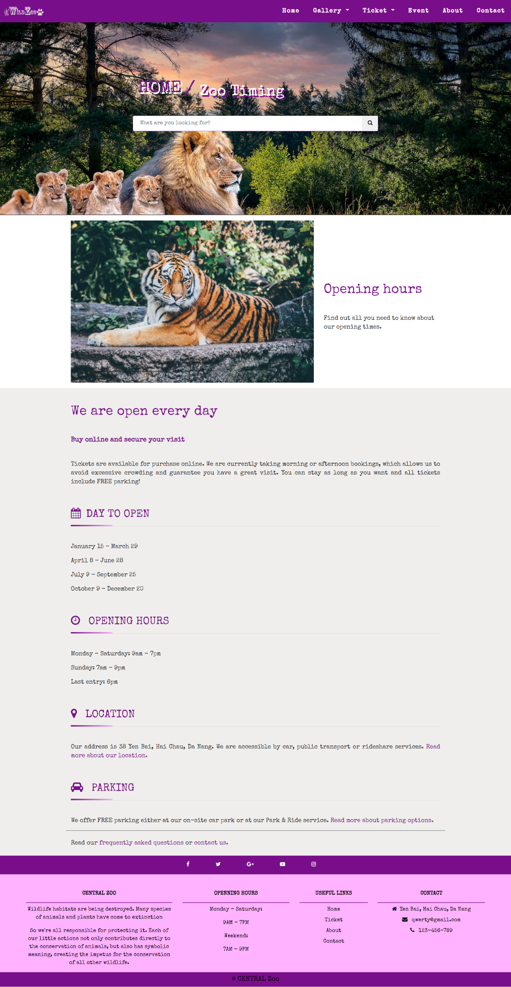

**Zoo Timing**

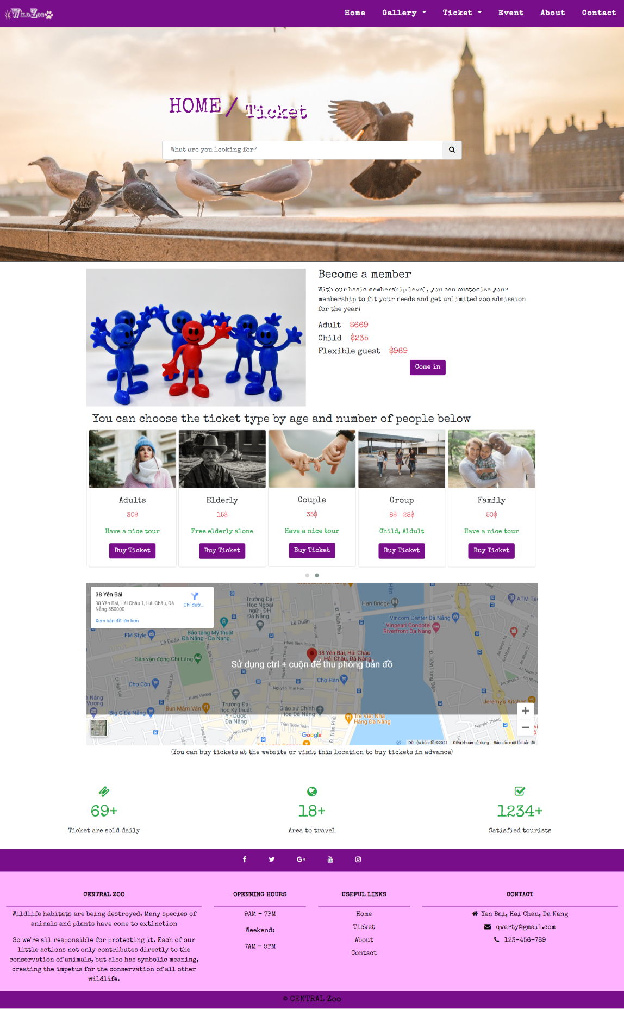

**Ticket**

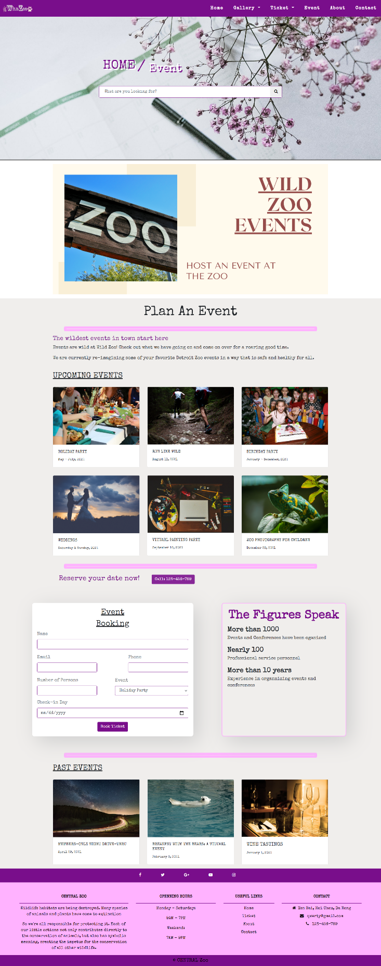

**Event**

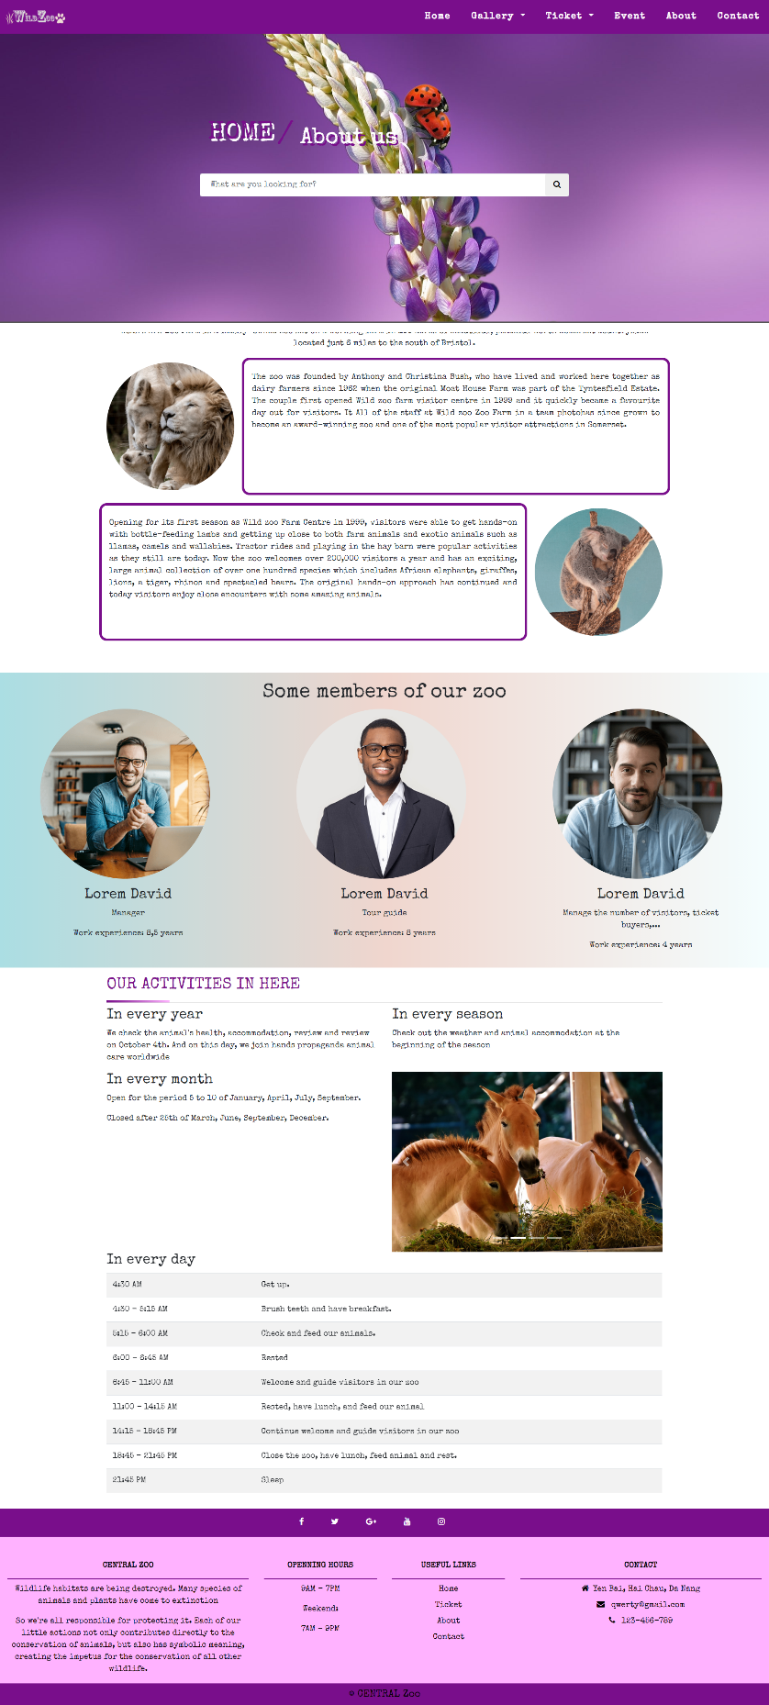

**About**

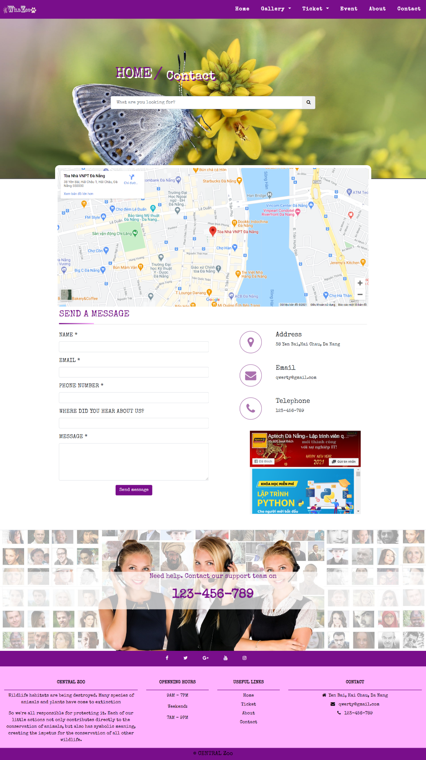

**Contact**

# **VIII. TECHNICAL**

* Software: Visual Studio Code, Photoshop, Balsamiq Wareframes…
* Brower: Chrome, Microsoft Egde, FireFox support design Responsive.
* The technical used to build the Website:
* HTML5
* CSS3
* Bootstrap
* Jquery
* JavaScript
* AOS Animation
* …

# **IX. REFERENCES**

* w3school.com
* getbootstrap.com
* pixabay.com
* stackoverflow.com
* youtube.com
* …

# **X. CHECKLIST**

|  |  |
| --- | --- |
| **Option** | **Validated** |
| Are the hardware and software correctly selected? | Yes |
| Do all the options present on the Web site display the correct result? | Yes |
| Are all the records properly fed into the appropriate database? | Yes |
| Have all the modules been properly integrated and are completely functional? | Yes |
| Have all the Design and Coding Standards been followed and implemented? | Yes |
| Is the GUI design consistent all over? | Yes |
| Do all text links lead to the appropriate Web site? | Yes |
| Do all the image links lead to the appropriate Web site? | Yes |
| Are all the images and links clearly visible on the page? | Yes |
| Is the Web page opening properly in all the tested Web browsers? | Yes |
| Is the Web page taking too long to load? | No |
| Is the navigation sequence correct through all the Web pages of the site? | Yes |
| Is the JavaScript code working as expected in all click events | Yes |
| Is there a function for users to purchase products? | Yes |

|  |  |  |  |  |  |
| --- | --- | --- | --- | --- | --- |
| **No.** | **Particulars** | **Yes** | **No** | **N/A** | **Comments** |
| 1 | Is the users table to login the Application on the user name and Password? |  | ✓ |  |  |
| 2 | Is there a form for users to enter Personal information when buying or put item into the cart | ✓ |  |  |  |
| 3 | Can the user to edit employee’s details after getting added? |  | ✓ |  |  |
| 4 | Is the user able to find a product’s wherever they want? | ✓ |  |  |  |
| 5 | Are the GUI contents devoid of spelling mistakes? | ✓ |  |  |  |
| 6 | Is the application user-friendly? | ✓ |  |  | Windows GUI is familiar with everyone |

# **XI. PROJECT PLANNING**

|  |  |  |
| --- | --- | --- |
|  | **Work** | **MEMBER** |
| Website | Navbar | All team |
| Footer |
| Home page |
| Library Photo | Le Dinh Tuan |
| Commemorative Photo | Hoang Trong Son |
| Animals Detail | Le Dinh Tuan |
| Zoo Timing | Hoang Trong Son |
| Ticket | Le Dinh Tuan |
| Event | Hoang Trong Son |
| About | Nguyen Thanh Hoai Chau |
| Contact | Nguyen Thanh Hoai Chau |
| Document | Cover & Menu | Hoang Trong Son |
| Acknowledgment | Le Dinh Tuan |
| Introduction | Hoang Trong Son |
| Requirements | Le Dinh Tuan |
| Problem Definition | Hoang Trong Son |
| Site Map | Le Dinh Tuan |
| Gui of Prototype | Hoang Trong Son |
| Gui of Website | Le Dinh Tuan |
| Technical & References | Hoang Trong Son |
| Checklist | Le Dinh Tuan |
| Conclusion | Hoang Trong Son |
| Project Planning | Le Dinh Tuan |
| Slide |  | Nguyen Thanh Hoai Chau |

# **XII. CONCLUSION**

CENTRAL Zoo includes Homepage, Gallery, Ticket, Event, About, Contact.

However, this website also needs to be developed and upgraded.

Here is the direction of development:

* Complete the missing parts of the website.
* Mobile App Development.
* Build chat box for customer support.
* Create profiles to store user data.
* Build Back-end for the website.
* Upgrade static web to dynamic web using Java, C #, PHP, Ruby ...
* …